Table of Contents

Executive Summary 2
I. Introduction and Statement of Purpose 4
II: Target Segment’s Market Size in Units and Dollars 5
III: Product, Promotion, Pricing Strategy and Placement 9
IV: Startup Costs United Health Group 15
V. Costs of Goods Sold 17
VI. Revenue Forecast 18
VII. Conclusion 20
References 21

Executive summary

The UNH is acknowledged as the leading healthcare organization in the United States; the corporation is focusing on extending its services to other countries. After evaluating several growth factors, China was identified as the best country or market for the company's expansion as a result of possible success factors the country presents.
Introducing new products or a brand to a new market is a challenging process. The process requires strategic measures and plans to ensure that the brand has effective entry strategies that could be evaluated upon their effectiveness to gain acceptance and compete effectively with already existing companies. Arguably, most of such entry requirements and strategies have significant impacts on various aspects of organizations market mix. New target market requirements, needs and culture, for instance, would push for various changes in products with the aims of attracting consumer preferences and providing consumer satisfaction to the new markets.
Group Three recommended UNH launch in China due their large population and technologically savvy population within the country. UNH is a technology based company, and China’s internet user base is currently behind only the United States and China with 243 million internet users. Though technology is a significant reason UNH should launch in China, the country’s healthcare industry, is a substantial factor in the country’s selection.Marketing Plan Group Three will recommend to UnitedHealth Group in order to successfully launch their healthcare market in China.
In consideration of entering into a new market business strategy, it is important to consider the target market and its size. UNH will be able to make a good-conscious business decision that which aligns with its marketing image by proceeding to do this action. It allows for a higher profitable outcome in which Chinese citizens’ healthcare is vastly improved.
UNH’s market developmental strategy will focus on market saturation and market penetration. UNH will utilize the ‘four Ps’ of marketing which are: Promotion/Positioning. Product, Pricing, and Placement/Distribution. Through these key marketing factors UNH should successfully gain significant market share within the Ping An company. Entering and successfully establishing service in a country can be difficulty, therefore the marketing plan will key in on the middle class aged 25 to 54 year and diabetes populace of China.

Introduction
The purpose of this paper is to provide a marking strategy for United HealthGroup Inc. to enter the Health Insurance market in China via a joint venture with Ping An Health Insurance Co., Ltd. A successful marketing strategy involves “the concept of building an organization around the profitable satisfaction of customer needs…[while] achiev[ing] success in high-growth, moderately competitive markets (Marketing Strategy, n.d.). This marketing strategy involves the marketing mix known as the 4 P’s: product conception, pricing, promotion and placement of our service (The Marketing Mix, n.d.). Utilizing this plan will give optimal access to our target buyers - diabetic adults and millennials.
UNH is the leading managed health care corporation in the United States, with total revenues of over $180 billion for FY2016 (“UnitedHealth Group Inc.”, 2016). Of its two primary subsidiaries, UnitedHealthcare (UHC) and Optum, UHC will be the target for expansion, bringing in the highest potential and accounting for over 80% of total revenues. This business segment focuses on employer and individual health care plans, along with government funded Medicare programs for age qualifying individuals. The industry itself remains competitive, with UNH facing stiff competition from the likes of Aetna, Anthem, Cigna and Humana, its top four contenders. Together, these five companies brought in over $385 billion in revenues for 2015, placing them within the top 80 of the Fortune 500 (“Fortune 500”, n.d.). Subsequently, this makes the field of healthcare very attractive to new entrants and investors alike, as they boasted an average return on investment of 8.94% just last year (“Health Care Providers”, n.d.).
China was selected as the target country for expansion due primarily to its large population, anticipated high growth, favorable government legislation and a strong healthcare need. UNH’s target markets are diabetics and millennials.
Target segment’s market size in units and dollars
Market share can be determined by units sold, customers served or dollar volume (Peterson et. Al, 2014). Unit market share measures the percentage of units sold by a company compared to total units sold in the market, while revenue market share measures the revenue of a company compared to total revenue in the market” (Boundless, 2017). Customer market share measures a company’s percentage of the market compared to that of the entire market.
To determine customer market share and revenue market share volume, we will use the following formulas against our two target markets, diabetes sufferers and Millennials:
- number of target customers x penetration rate = Market Volume, &
- market volume x average value= Market value
Diabetes
In 2016, 110 million Chinese citizens suffered from diabetes. Diabetes comes in two forms, type 1 and type 2. Type 1 diabetes is an autoimmune disease which prevents the body from producing insulin and mainly affects children and young adults who are likely born with it (IDF, n.d.). Type 2 diabetes is a metabolic disorder that results from the body’s inability to make effective use of the insulin produced (IDF, n.d.). Type 2 diabetes mainly affects adults over the age of 40 (95% of all type 2 cases are from this age group) however, with poor genetics, the prevalence of obesity, as well as the lack of an appropriate diet and or physical activity among younger individuals, they are developing type 2 diabetes thus creating the potential for the number of diabetics in China to climb even higher (IDF, n.d.). Additionally, almost 500 million more suffer from so-called “prediabetes” (Sjolin, 2016). Being prediabetic poses a risk factor for developing type 2 diabetes (WHO, 2016). If we add just 25% (125 million) of the 500 million prediabetic citizens to the current number of diabetics, the number of diabetics in China would more than double to 235 million. Notwithstanding, China is expected to have more than 151 million people with diabetes by 2040 up from their current number of 110 million (Sjolin, 2016).
Target Market- Based on the 2016 numbers of total diabetes sufferers, we will estimate our number of target customers at 110 Million. Based on the 2040 numbers, our 2nd set target customers will number 151 million. As mentioned before should 25% of the prediabetic population become diabetics we can see the current number of 110 million balloon to 235 million diabetes sufferers.
Penetration rate- For our target penetration rate, we will go with 5 percent because diabetes coverage is in high demand due to the current gaps in healthcare coverage as well as the desire of individuals not to lose their life savings to healthcare issues. This can be considered mission critical although a service such as this is not mandated. If marketed based on the dire threat that diabetes pose to Chinese citizens it is reasonable to aim for 5% market share above the modest 1% being used for our millennial market volume.
Market Volume- Using the 2017 numbers of current diabetes sufferers (110 million), if UNH can gain just 5% of the market with their supplemental diabetes insurance UNH can have 5.5 million customers in this niche market alone. By 2040, if projections remain constant, UNH can have 7.5 million customers, and in the event that 25% (125 million) of prediabetics become diabetic the customer share (at 5%) can reach 11.7 million customers.
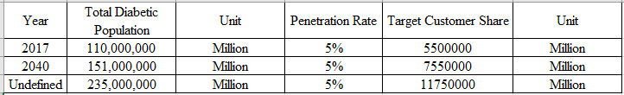
Table 1. 2017, Projected 2040, and undefined Diabetic Population with respective target customer share
China’s Diabetic Insurance Market Value
The market size (value) is determined by the formula market volume x average value= Market value. UNH’s 2017 market volume is 5.5 million customers, when multiplied by the cost of each unit of sale $450 (annual) the product is a market value of 2.47 Billion dollars. Of course, this increases when calculating in the projected total customer share in 2040 ($3.39 billion) and the potential 25% of the prediabetic population ($5.28 billion) shown in table 2.
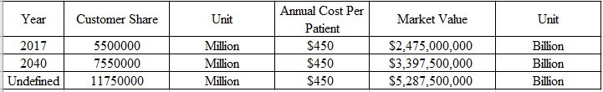
Table 2. China’s Diabetic Market Value for 2017, 2040 and undefined
Type 2 Diabetes projections
UNH can further segment the diabetes market to type 2 diabetics. In the next three to five years the type 2 diabetic population is expected to grow from 55 million to 60 million in 2020, to 70 million by year 5 (2022). Given a penetration rate of this market at 5% the target market volumes are 2.75, 3.0, and 3.5 million customers respectively.
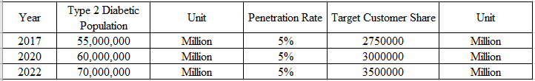
Table 3. 2017 Type 2 diabetes sufferers, Projected 2020 and 2022 type 2 diabetics, their penetration rate at 5% and each year’s respective target customer share
Taking those market share numbers and multiplying them against the annual cost per patient of $450, the market values are $1.2 (2017), $1.3 (2020), and $1.5 billion (2022).
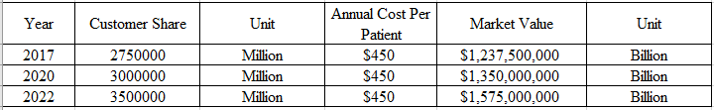
Table 4. 2017 Type 2 diabetes sufferers, Projected 2020 and 2022 type 2 diabetics, their penetration rate at 5% and each year’s respective target customer share
Millenials
Currently the millennial population (those between 18 and 35 years of age) in China is 385 million strong (Russell, 2016). The number of millennials in China is expected to reach over 400 million by 2020. We can further segment the Millennial Market by focusing on the Millennial Middle Class. Focusing on middleclass millennials will allow UNH to reach the best target i.e. those who can afford the monthly payments. The middleclass is projected to number 630 million by 2022 but how many of this number are millennials has not yet been discovered and as such no projections are available at this time.
Target Market- Our number of target customers (market) for 2017 is 385 million people. Our target customers projected for 2020 is 400 million people.
Penetration Rate- For our target penetration rate, we will go with a low percentage due to the fact that this product is not mission critical nor is it mandated through regulation and also because it is a product with a specialized purpose (Marsdd, n.d.). We will choose a market penetration rate of 1%.
Table 5. 2017 millennial population, Projected 2020 millennial population, their penetration rate at 1% and each year’s respective target customer share
Market Volume- Using the 2017 numbers of millennials (385 million), if UNH can gain just 1% of the market with our insurance products and services we can serve 3.85 million customers. For 2020 (400 million projected), UNH could potentially server 4 million millennials.
Market Value
The customer share for 2017 is 3.85 million multiplied by the annual cost per patient of $450, the market value is $1.73 billion. The customer share for 2020 is 400 million multiplied by the annual cost per patient of $450, the market value is $1.8 billion. 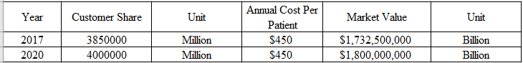
Table 6. 2017 millennial customer share, Projected 2020 millennial customer share, their annual cost per patient at $450 and each year’s respective market value
Product, Promotion, Pricing Strategy and Placement
There are no product modifications needed for UNH to enter the Chinese market. Currently, UNH provides customers with a range of policies from which to choose. Each client can customize his policies and plans to accommodate his needs.
Since UNH is looking to partner with Ping An Health in a Joint Venture, the two companies will share some of the promotion costs. First, UNH and Ping An Health will provide internet, magazine and newspaper advertisements promoting the new venture with the brunt of this endeavor falling onto the native corporation to ensure the wording and look are appropriate to best influence the indigenous community.
Secondly, UNH will leverage Ping An’s existing relationships to partner with the Chinese government with the goal being to receive an official endorsement as a way to gain market acceptance in China. A good relationship with officials will not only assist in promoting the company within the Chinese population but also increase UNH’s reputation with local competitors.
Third, to reach the millennial market share, UNH will create a promotion campaign that focuses on the family bond. This bond is an integral part of Chinese culture and UNH will emphasize its existing plans that provide discounts for family members and multi-person policies. The advertisements will focus not only on appealing to the traditional family unit of husband, wife, and children but will also include grandparents, aunts, uncles, and cousins.
To keep start-up costs down until UNH has a solid market share, UNH will sell policies and plans to the Chinese market through a newly created joint office with a direct sales force staffed with Ping An Health and UNH employees. The ideal would be to reach out to the native Chinese community through a direct sales force and the expatriate community through online sales. The online sales will continue to lean on UNH's existing infrastructure for the expatriate and English speaking communities. This proposal will best use the existing infrastructure of both companies efficiently. UNH will collaborate with Ping An to create a Chinese language website for later use with online sales for the native Chinese community.
Like the variety in the promotion and product placement, the recommend pricing strategy has multiple factors. For the Diabetes-specific native Chinese policies, UNH will utilize penetration pricing. UNH will set the initial price low for all diabetes-specific policies, medicines, and devices with the goal of attracting customers and gaining market share. The price can be raised later once UNH has gained market share and a firm foothold. A business that uses a penetration pricing strategy prices a product or a service at a smaller amount than its usual, long range market price to increase more rapid market recognition or to increase their existing market share (Kent, 2003).
Firms or businesses usually use the penetration pricing strategy when entering a new market. In marketing, it is a theoretical method that is used to lower the prices of the goods and services causing a high demand for them in the future (Spann et al., 2014). This strategy of penetration pricing is highly recommended due to the enormous amount of competition in the Chinese health-care market. Due to this situation, UNH will use the penetration strategy to gain consumer attention (Spann et al., 2014).
For the millennials, UNH will utilize relationship marketing to help with the pricing strategy. Abramson and Aihave identified shared values or goals as some of the key aspects of relationship marketing (Abramson et al., 1997). UNH will build on the family oriented promotions with providing family specific pricing. Most millenials, are of good health and have few medical expenses. However, many are supporting older generations and extended family members that are experience health issues.
For the millennials, UNH will use Price discrimination. This pricing strategy is the practice of setting a different price for the same product in different segments to the market. Specifically, UNH will utilize second-degree price discrimination. The second-degree strategy provides a volume discount to high-frequency buyers (Chang & Chen, 2016). This practice encourages the purchase of more items to increase the discount. UNH will offer customers of multi-person or multi-focused policies a price range that will decrease the per-person costs as more items are purchased.
Marketing Costs
When it comes to marketing, the saying “spend money to make money” couldn’t be truer. The health insurance industry is no exception, either. According to the American Marketing Association (AMA), particularly in the insurance industry, revenue growth is directly tied to the amount spent on marketing, regardless of the size of the firm (Conick, 2016). The AMA also notes that companies who spend at least 15% of their revenue on marketing tend to see a 20% year over year increase in revenue. UNH will aim to follow a similar plan, and initiate aggressive marketing and advertising campaigns to foster explosive growth in the new Chinese market. Although they may not need to match the $169 million spent on advertising in 2013, due to splitting efforts with Ping An Insurance in the joint venture (JV), they still will not shy away from excessive spending in the first few years in the new market in order to capture market share (Flory, n.d.).
Product Modifications
There will be no product modifications needed, thus none of these costs are associated with the marketing plan expenses.
Distribution Costs
Distribution costs will be incurred through the use of a direct sales force for both physical and online sales. All of the 9 key sales personnel will take some sort of alternating role in both physical sales and back office sales, eliminating the need for a call center. For physical, the JV will provide three reps available in the office during business hours, and two reps always in the field doing road shows or presentations twice a week. At the start, each team member will be provided 12 company branded polo shirts ($360), 2000 business cards ($80), a leather briefcase ($200), a laptop ($1,200), a cell phone ($200), and a $1,000 allowance for miscellaneous items per month (entertaining clients, etc.). Additionally, we will need to add in the monthly cell phone service ($100), annual business card re-stock ($80) and monthly allowance ($1,000) in ongoing costs per employee. For the online space, the company will require a professional website capable of processing sensitive personal information. UNH will contract a private company for the design, maintenance and support of this website for a startup cost of $12,000 upfront and ongoing fees of $1,000 a month. Additionally, phone services and dedicated internet will be relied on heavily for all personnel. UNH will contract with a local ISP to procure VoIP phone services and a dedicated 50 megabyte Ethernet internet circuit for $3,000 initially and $1,800 per month thereafter. Final costs for the distribution aspect total $184,760 to startup and $170,760 ongoing per annum. Major assumptions made in this portion include replacing branded shirts, briefcases, laptops and cell phones on an annual basis, with the old items being recycled or donated to a non-profit for a tax credit.
Advertising/Promotion Costs
UNH will rely on several advertising and promotion related materials that promote their theme of “family bonding”. Utilizing Vistaprint, UNH will obtain 1,200 brochures ($600) and 100,000 post cards ($3,500). Additionally, they will buy magazine ($800), newspaper ($400) and internet ($500) advertising slots on a monthly basis. This brings the total startup costs for advertising and promotion to $24,500, and the same amount for ongoing costs.
Sales Incentives/Rewards
The sales team will be compensated heavily in salary, and therefore will not be allowed to draw commissions on policy sales. However, UNH will give out quarterly bonuses at each review period, where sales employees will be allowed to earn up to 25% of their salary as a one-time bonus. The current sales team salary is a total of $469,081.12 for all nine employees. As 25% of this amount is available four times a year, that gives us a grand total equal to their combined salary ($469,081.12 *0.25 * 4) in incentive money at startup and ongoing.
Marketing/Sales Headcount
The marketing/sales headcount has already been established, and will not be included twice in this analysis. However, for reference, the salaries of the 9-member sales team are as follows:
- Division Vice President: $147,000 per year
- Senior Manager: $130,000 per year
- Assistant Manager: $87,309.60 per year
- Supervisor: $61,116.72 per year
- Employees/Sales Reps (5): $43,654.80 per year
- Total: $469,081.12 per year
 | Start-Up | Year 1
Product Modifications | $0 | $0
Total | $0 | $0
Distribution Costs
Branded Shirts | $3,240 | $3,240
Business Cards | $720 | $720
Briefcase | $1,800 | $1,800
Laptop | $10,800 | $10,800
Cell Phone | $1,800 | $1,800
Cell Phone Service | $10,800 | $10,800
Allowance | $108,000 | $108,000
Website Design and Support | $23,000 | $12,000
Phone and Internet | $24,600 | $21,600
Total | $184,760 | $170,760
Advertising/Promotion Costs
Brochures | $600 | $600
Post Cards | $3,500 | $3,500
Magazine Slots | $9,600 | $9,600
Newspaper Slots | $4,800 | $4,800
Internet Slots | $6,000 | $6,000
Total | $24,500 | $24,500
Sales Incentives/Rewards
Total Bonuses | $469,081.12 | $469,081.12
Organizational Sales Headcount
*Marketing/Sales Headcount | $469,081.12 | $469,081.12
Final Total | $1,147,422.24 | 1,133,422.24
Table 7: Summary Table – Marketing/Sales Costs *Already included in organizational headcount from Week 8.
Startup Costs- UnitedHealth Group
Startup costs refer to the costs that companies incur at the initial stage before making their first sales (Hobbs., et al, 1988). Sawyer (2015) explains that these costs are important in projecting the actual expectations of the business as well as calculating the break even points of the business. Some of the main common startup expenses include research costs, legal costs, consultant costs and others as may relate to the type of business involved (Myers., et al, 1986).
Additionally, UNH’s activity in China via mobile clinic operations contributed greatly to the startup costs. Regarding employees; UNH will have 114 employees that consist of 2 senior vice presidents, seven vice presidents, ten managers, ten assistant directors, ten supervisors, along with 45 employees. Besides, there will be 30 employees hired to work at the mobile clinic. Analyzing the industry's average and median salaries as well as the financial costs of operating the mobile clinics; the UNH group will be required to spend $8,646,729.2 in the first year. Therefore, a joint venture is an appropriate means for the corporation to enter China market.
The table below uses estimate values to calculate and demonstrate the startup costs that UnitedHealth Group would incur when establishing in China for the first 6 months required in setting up the business.
Startup Expenses | Costs
Legal | $100, 000
Translation | $20, 500
Initial Multimedia Website Design and Development | $100, 700
Initial Hiring and Training Salaries  2 Senior vice president  7 vice presidents  10 senior managers  10 assistant managers  10 supervisors  45 employees  Total expenses in salaries | $400,000  $1,050,000  $1,300,000  $873,096  $611,167.2  $1,964,466  $6,198,729.2
Initial Marketing | $30, 000
Initial Research and Development | $40, 500
Trial and Testing | $20, 000
Consultancy | $100, 000
Expensed equipment | $30, 500
Location establishment | $50, 000
Total Startup Costs | $8,646,729
Table 8: UnitedHealth Group Marketing plan Startup Costs in China
Costs of Goods Sold
The cost of goods sold refers to the total costs of products or services that are sold to the customer (Datar., et al, 2013). Normally, it is reported on businesses income statement when reporting the sales revenues. Usually, the cost of goods include costs incurred via suppliers, the costs to get the products and services into inventory and costs associated with getting them ready for sale (Watson & Everett, 1993). For products, manufacturing costs fall into this category (Sawyer, 2015). However, in companies offering services, the costs of goods comprises the costs incurred on service personnel and other service related expenses that may be incurred when offering the services to the customer (Myers., et al, 1986).
The table below shows the estimate of the costs of goods for the first year of operation in China.
Expenses | Costs
Medical Personnel | $510,000
Mobile Clinics  2 mobile clinics  Salaries  8 doctors  16 nurses  6 support personnel  Total expenses | 700,000  768,000  800,000  180,000  $2,448,000
Production of Content | $220,000
Managing Site | $115,000
Marketing | $304,500
Total Cost of Goods | $3, 21,473,500
Table 9: Cost of Goods for UnitedHealth Group in China
Revenue Forecast
In order for UNH to capture true revenue over the first 3 years of entry, they must forecast their expenses and sales. Considering that China’s diabetic population is such a large potential market it wasn’t too hard finding data to support our narrative. 5.5 million potential consumers represent 5% of the total diabetic market. We anticipate being able to convert 10% (550,000 customers) of our targeted market into actual sales. According to a recent ‘total medical cost of diabetic patients’ study, Huang stated, “our results showed an increasing trend in total medical cost (from 2,383 to 2,780 USD, p = 0.032) and diabetes related cost (from 1,655 to 1,857 USD) for those diabetic patients” (2016). However, with the average salary in China being $8,655 and $2,000 for rural citizens, UNH price our service at $450/per patient which depends on location and effectively cuts the competition while gaining a piece of the marketplace (Chang, 2016).
I used the following formula to calculate the yearly sales:
Number of customers x average sales price x number of yearly purchases = yearly projected sales
10% of our targeted market equates to 550,000 sales per year. If you multiply that number by average sales price, which is $450/per patient, you get about $247.5 million in revenue per year. Once you deduct your expenses you arrive at the total revenue. As the market continues to grow we intend on gaining new customers by retaining our knowledgeable staff and keeping our prices affordable in order to control the market.
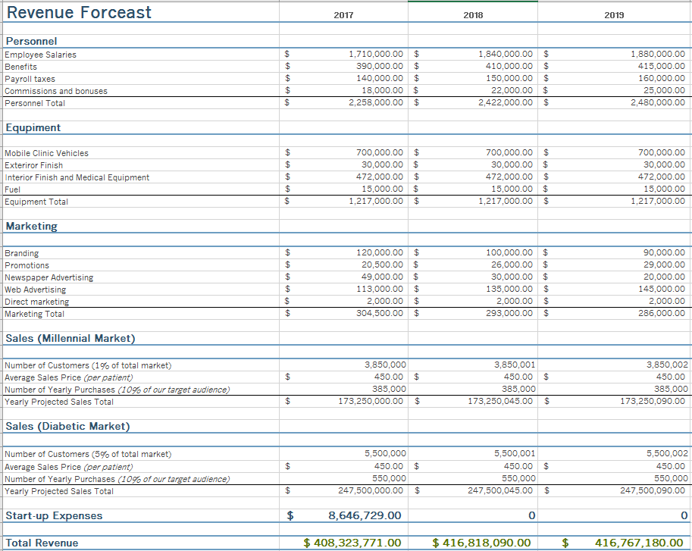
Table 10: Total Revenue forecast

Conclusion

References
Abramson, N. R., & Ai, J. X. (1997). Using guanxi‐style buyer‐seller relationships in China: reducing uncertainty and improving performance outcomes. Thunderbird International Business Review, 39(6), 765-804.
Boundless. "Calculating Market Share." Boundless Marketing Boundless, ‎29 ‎Mar. ‎2017.
Retrieved ‎31 ‎Mar. ‎2017 from https://www.boundless.com/marketing/textbooks/boundless-marketing-textbook/the-marketing-environment-3/internal-factors-30/calculating-market-share-161-4046/
Chang, R. (2016). Here’s What China’s Middle Classes Really Earn – and Spend. Retrieved
from: https://www.bloomberg.com/news/articles/2016-03-09/here-s-what-china-s-middle-class-really-earn-and-spend
Chang, W. W., & Chen, T. L. (2016). A Note on Second-Degree Price Discrimination: The Optimal Quantity-Discount Pricing Schedule. Browser Download This Paper.
Conick, H. (2016, May 16). Survey Says: Insurance Companies That Spend More on Marketing
Make More. Retrieved April 01, 2017, from https://www.ama.org/publications/MarketingNews/Pages/insurance-companies-spend-marketing-make-more.aspx
Datar, S. M., Rajan, M. V., Wynder, M., Maguire, W., & Tan, R. (2013). Cost accounting: a managerial emphasis. Pearson Higher Education AU.
Flory, M. (n.d.). Bonus Chart: Breakdown of Insurance Company Ad Spend. Retrieved April 01,
2017, from https://www.ama.org/publications/eNewsletters/MHSNewsletter/Pages/Bonus-Chart-Breakdown-of-Insurance-Company-Ad-Spend.aspx
Hobbs, W. J., Hermon, G., Warner, S., & Shelbe, G. B. (1988). An enhanced dynamic programming approach for unit commitment. Power Systems, IEEE Transactions on, 3(3), 1201-1205.
Huang Y, Vemer P, Zhu J, Postma MJ, Chen W. Economic Burden in Chinese Patients with
Diabetes Mellitus Using Electronic Insurance Claims Data. Khamseh ME, ed. PLoS ONE. 2016;11(8):e0159297. doi:10.1371/journal.pone.0159297.
IDF. (n.d.). Diabetes. Retrieved from:
https://www.idf.org/webdata/docs/background_info_AFR.pdf
Kearns, S. (2017, March 16). How to Forecast Your Revenue. Retrieved April 01, 2017, from
http://quickbooks.intuit.com/r/revenue/forecast-revenue/
Kent, M. (2003). The Pricing Strategy Audit.
Marsdd (n.d.). How to estimate market size: Business and marketing planning for startups.
Retrieved from: https://www.marsdd.com/mars-library/how-to-estimate-market-size-business-and-marketing-planning-for-startups/
MOBILE CLINIC COST. (n.d.). Retrieved April 02, 2017, from
http://odulair.com/mobile-clinic-cost-medical-van-cost.html
Myers, C. W., Shangraw, R. F., Devey, M. R., & Hayashi, T. (1986). Understanding Process Plant Schedule Slippage and Startup Costs. Rand.
Nordisk. (2011). Changing Diabetes in China. Retrieved from:
https://www.novonordisk.com/content/dam/Denmark/HQ/Sustainability/documents/blueprint-changing-diabetes-in-china.pdf
Peterson, S., Jaret, Peter. Schenk, B. (2014). How to calculate market share for your business
marketing plan. Retrieved from: http://www.dummies.com/business/start-a-business/business-plans/how-to-calculate-market-share-for-your-business-marketing-plan/
Russell, C. (2016). New Youth: Understanding China’s Millennials. Retrieved from
http://knowledge.ckgsb.edu.cn/2016/02/03/demographics/new-youth-understanding-chinas-millennials/
Sawyer, T. Y. (2015). Cost of Goods Sold and Inventory Model: Plot Your Costs and Margins. In Financial Modeling for Business Owners and Entrepreneurs (pp. 105-126). Apress.
Sjolin, S. (2016). China’s diabetes boom promises $23 billion pot for drug makers. Retrieved
from: http://www.marketwatch.com/story/chinas-diabetes-boom-promises-23-billion-put-for-drug-makers-2016-01-15
Spann, M., Fischer, M., & Tellis, G. J. (2014). Skimming or penetration? Strategic dynamic pricing for new products. Marketing Science, 34(2), 235-249.
Watson, J., & Everett, J. (1993). Defining small business failure. International Small Business Journal, 11(3), 35-48.
WHO. (2016). Rate of diabetes in China “explosive”. Retrieved from:
http://www.wpro.who.int/china/mediacentre/releases/2016/20160406/en/

